Name:
Tutor:
Course:
Date:
Microhardness Testing
Abstract
The experiment's objective was to familiarize the students and learn how cold work affected the specimen of annealed of cartridge brass, 30 weighted percentage Zn and 70 weighted percent Cu. The experiment was set up to analyze the percent of cold work. The students polished the brass specimen starting with the 240, 320, 400, and 600 grit sandpaper after having finished wrapped-up the process with 1 and 0.5-micron polishing. There were 6 samples within the experiment that arranged from 0% to 50% cold work. They were supposed to make use of three different tests which include; Rockwell hardness, Vicker's micro hardness, and Moh's hardness. After polishing the brass (specimen), it was analyzed using the microscope in order to view the grains.
Introduction
The experiment was geared toward understanding the micro-structure of materials. There was a small percentage of the energy that caused plastic deformation. When energy increases, it altered the mechanical and physical properties of the specimen. Majorly, as the process of cold working progresses, there is a marked increase electrical resistivity and hardness (Campbell, 2008). When energy increases (internal energy), it causes an increase in the dislodgment density as well as the density of point of flaws. At some point, grains become evidently stretched out in the direction of working. The cold work is normally reached at after subjecting the brass (specimen) to the rolling process. The process of rolling makes the atoms to be disarranged since it involves compressing of the material. Thus, after subjecting the specimen through the rolling, the grains are obvious and cracks. The cracks seen the students saw on the surface of the specimen had been caused by the scratching utensils of the Mohs’ kit.
Cold working makes metals to strengthen by changing its shape without heat being applied on it. Cold working process involves subjecting the metal that needs to be worked on to mechanical stress so that it can cause a permanent change to the its crystalline structure. This process is carried out on the metal at a temperature which is below its recrystallization point (Lula, 1980). The technique is in most cases applied to copper, zinc, aluminum, and steel. After these above-mentioned metals are cold worked, they incur permanent defects change in their crystalline makeup. Such defects lowers the ability of crystals to move within the metal structure and thus the metal becomes resistant to further deformation (Campbell, 2008).
Cold rolling is the most widely and commonly used method of work hardening. This process involves the metal that needs to be cold worked on being passed through pairs of rollers in order to reduce its thickness or in other words to have its thickness uniform. While the metal is passed through the roller, it is compressed and its grains appears to become deformed.
Procedure
The lab technician divided the students into six groups. Each of the group was responsible for producing a specific percentage of cold work that ranged from 0% to 50%. Each of the formed groups was provided with a cartridge brass specimen. They kicked-off with measuring the initial thickness (t1) of the specimen. Before the groups were allowed to start rolling the specimen on the rolling meal they were taken through a thorough safety instruction session regarding how they were supposed to use the rolling mill in the laboratory. After the safety session, each of the group began to roll their specimen on the rolling mill. At this given point, they were supposed to use a wooden stick to push the specimen into the rolling mill so as to keep-off their hands from the rolling mill. After every roll, the students stopped in order to measure the thickness of the specimen so as to ensure that its thickness did not go beyond that which they expected.
The students used numbered utensils that were picked from the Moh's hardness kit. They started with the utensils that had the lower number and tried to scratch the specimen. After several attempts to have the surface of the specimen scratched, they stopped the process after it was scratched. The Moh’s hardness number must be below the number which caused the scratching of the specimen. After scratching of the brass specimen, the students placed the specimen onto the Rockwell hardness tester, and they recorded the B-scale readings. After placing the specimen on the scale, the students adjusted the large needle until it read zero as the small needle was facing upwards. After taking the readings, the lever was once again repositioned to the point it originally was. The students repeated this part and recorded the multiple reading that was showing on the scale. They added the reading and calculated the average reading. After finishing calculating for the average reading of the B-Scale, the students placed the specimen on the cut-off tool. They cut off around a one-half inch of the specimen. They polished the remaining smaller part of the specimen so that they could make use of it in the steps that followed. Before placing the brushed specimen on the piston, they turned on the heat of the molding equipment. They released the pressure so that the piston could be lowered. They poured one measure of the powder into the cylinder to clean the surface. They then placed the lid to cover the top and then released pressure and increased it, but without overloading the equipment. They waited for around five minutes and then released the pressure from the cylinder. They then removed the specimen by the caution of the increasing temperature. Water was turned on at the polishing station. They put the specimen on the polish machine and kept on observing its surface until the scratches that were cut off by the machine were all gone. They started with the 240 grit paper and then did the same with the 320, 400, and 600 grit papers after which the students put off the running water. They polished the specimen on the 1-micron wheel and on the 0.5-mocron wheel respectively. At the latter stage, the students ensured that the specimen was washed with a specific solution every 5 seconds. They also ensured that they rinsed the specimen. Later on, the students smeared alcohol on the specimen's surface and allowed it to dry. They then viewed the grains on the specimen's surface and noted the difference that were evident with the values that had been recorded using the Knoop hardness test.
Results and Discussions
The data that had been obtained at the end of the experiment was almost as expected. The cold work of brass yielded results that were almost similar to the ones that the students were expecting. Cold work increased the Rockwell's hardness at 0% = 54.04 to the 50% = 81.89. Following the data recorded on the experiment, the percentage of cold work increased as shown in figure2 and figure two shown the connection flanked by percentage cold work and Brinell hardness. In addition, the tables 1 and 2 show sample calculation of cold work done on brass and the effect on hardness. After polishing the grains were visible when viewed by use of the microscope. The grain size was thus analyzed to estimate the strength of the material. The other aspect of the grains was observed where cracks existed in the surface of the specimen and that the cracks were thought will develop with time, and at the end, they were to destroy that particular section through weakness.
Table 1. Cold Working Brass

Cold Working Brass: Effects on Hardness & Microstructure
% CW | T₁ ln | T₂ ln | Actual t₂ ln | Actual % CW | Mohs | Rockwell B
0% | 0.50 | 0.50 | 0.50 | 0.00 | 3.50 | 54.04
10% | 0.47 | 0.45 | 0.44 | 12.49 | 3.50 | 70.42
20% | 0.48 | 0.40 | 0.38 | 19.56 | 3.50 | 84.21
30% | 0.48 | 0.33 | 0.32 | 30.98 | 3.50 | 79.56
40% | 0.49 | 0.29 | 0.29 | 39.23 | 3.50 | 84.65
50% | 0.49 | 0.25 | 0.29 | 46.12 | 3.50 | 81.89

Figure 1. % cold work vs. Rockwell’s hardness

Figure 2. %cold work vs. Moh’s hardness

Table 2. Vickers hardness
% CW Vickers
 | 1 | 2 | Average
0 | 101 | 99 | 100
10 | 123 | 131 | 127
20 | 179 | 149 | 164
30 | 201 | 187 | 194
40 | 232 | 224 | 228

Figure 3. %cold work vs. Vicker’s hardness

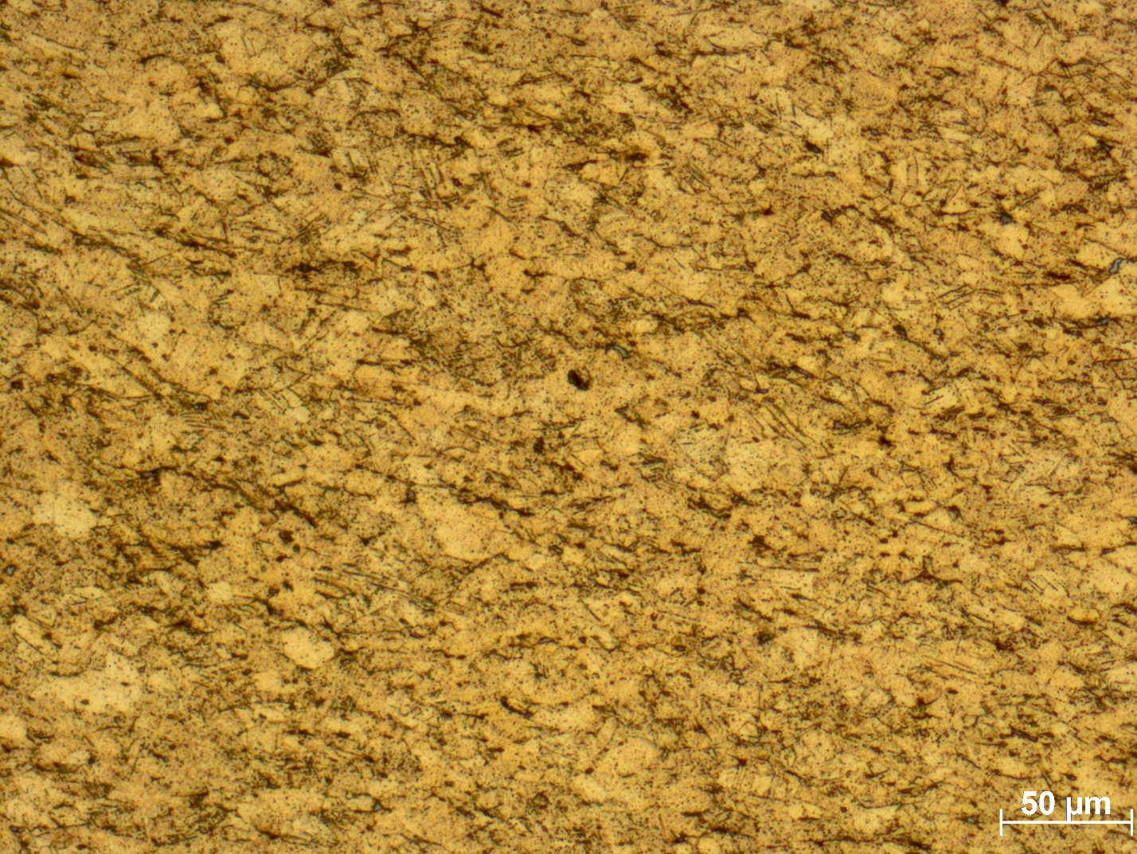

The grains of the metal appears to be clearly visible when viewed under the microscope.
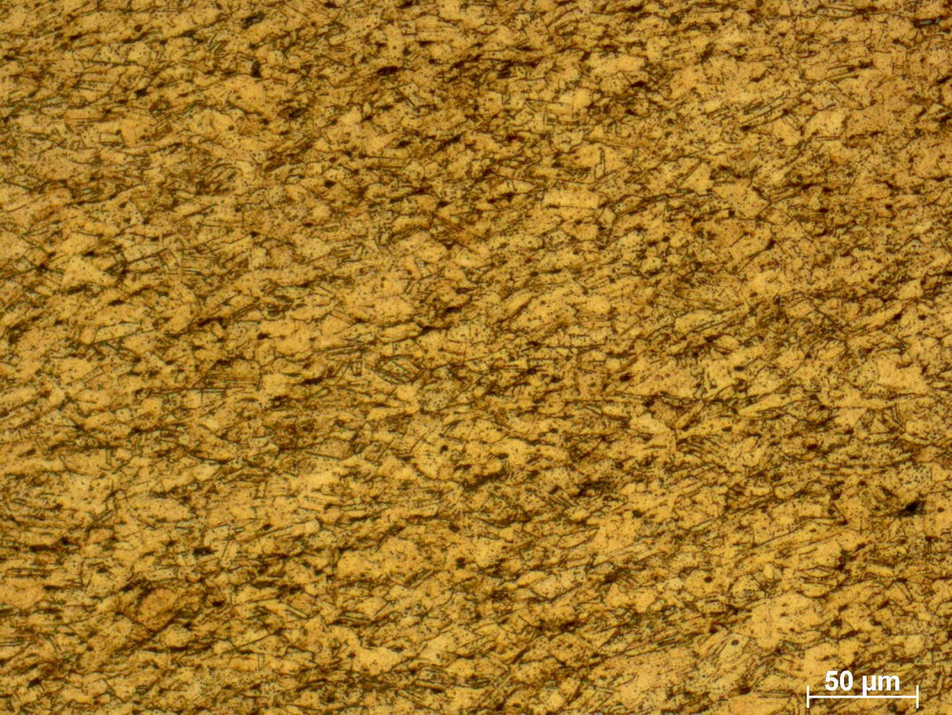
The grains are clearer than those in the figure above. Cold rolling seems to have started taking effect since it is the one that causes the metals to deform.
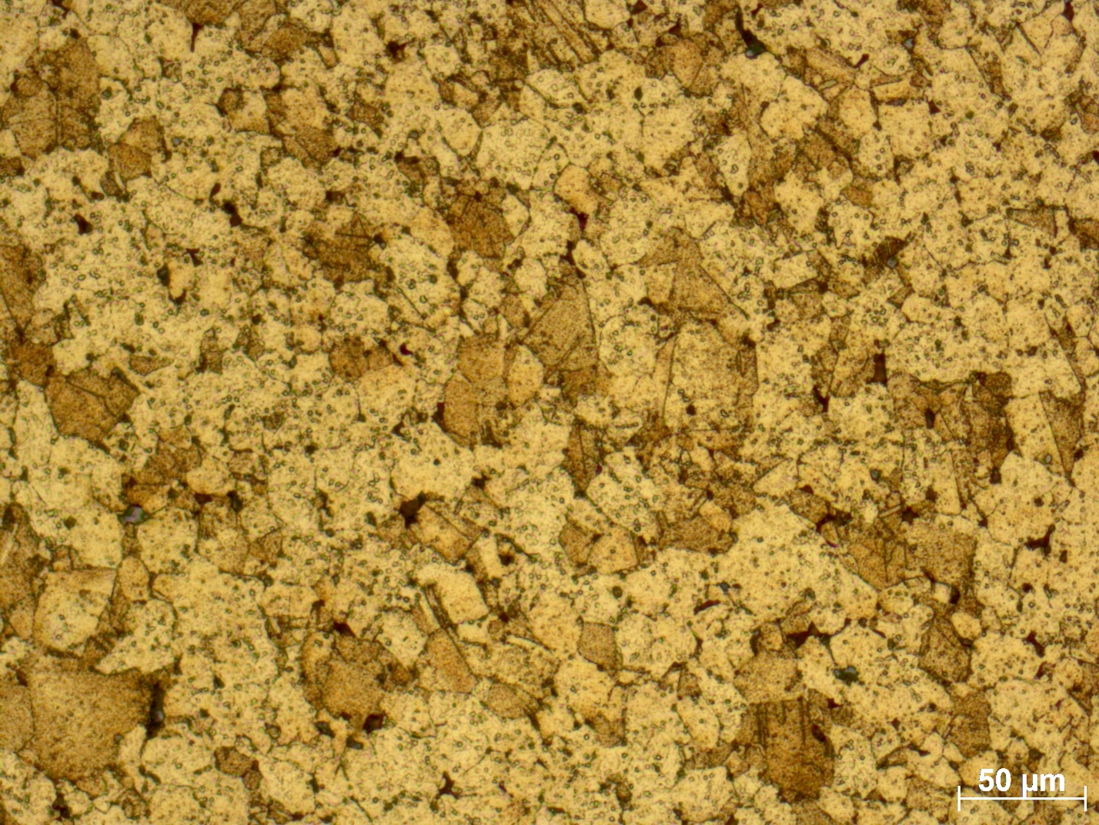
In this figure, cold worked was just starting to take effect. The grains are not visible.
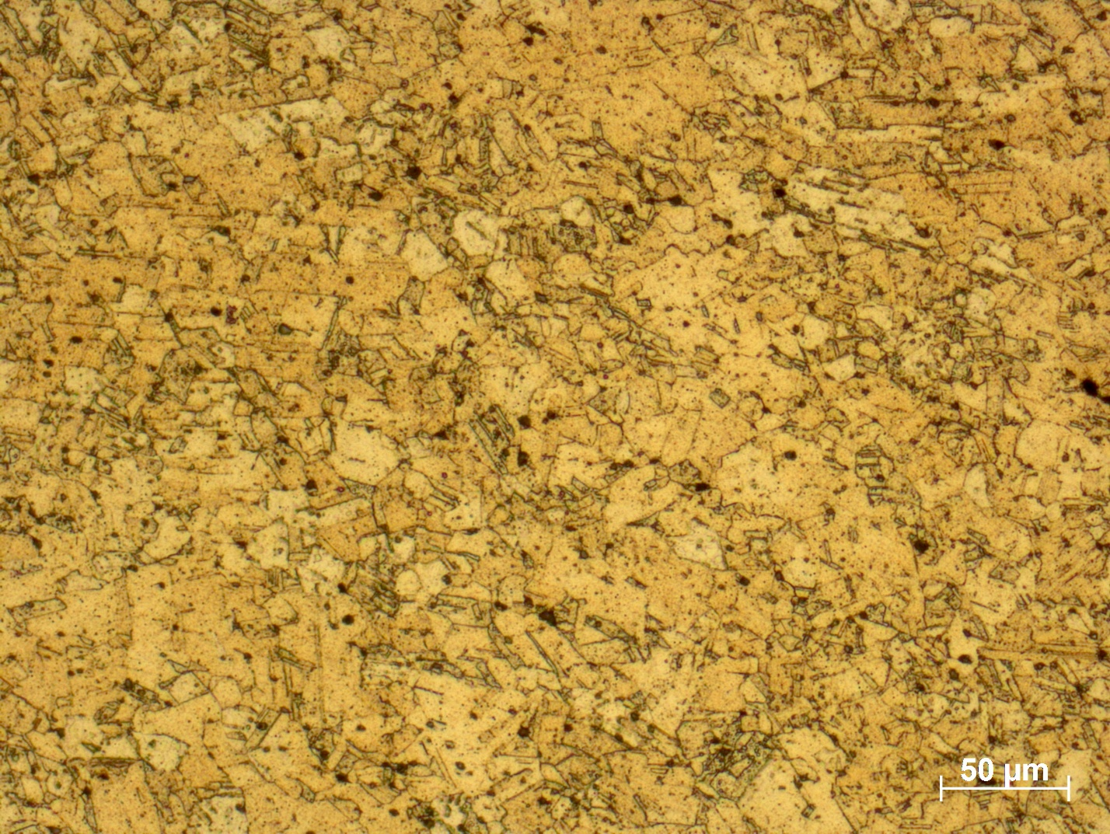
The grains have already formed on the metal surface. Cold rolling involves passing the metal through pairs of rolling metals so as to deform its structure.

The grains are not that visible. Cold rolling had just started to take effect.
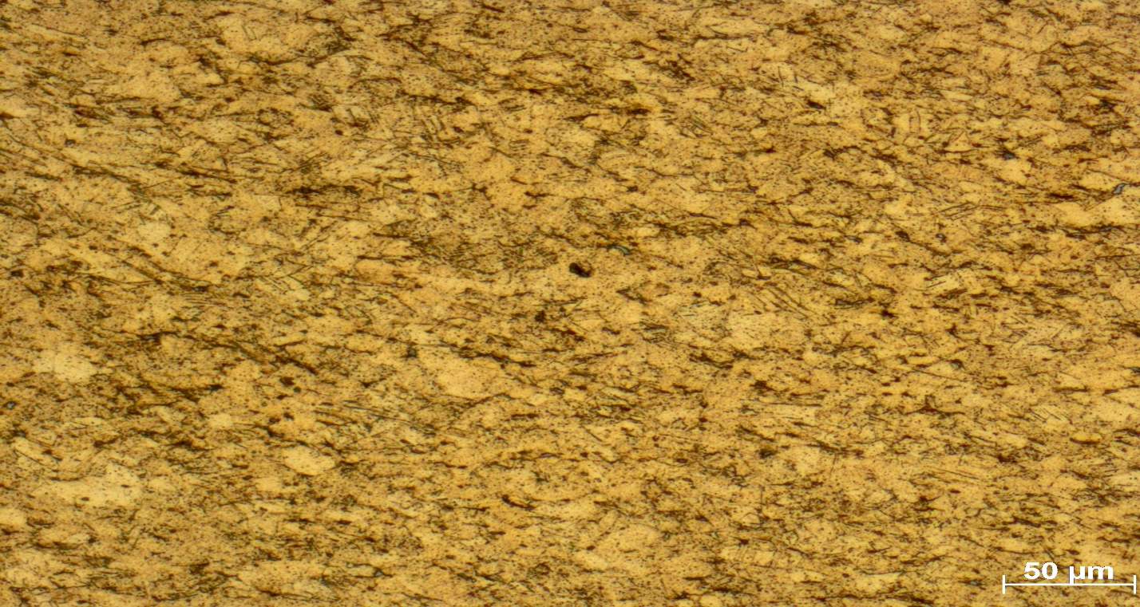
The grains are not that visible. Cold rolling had just started to take effect.

Conclusion
The experiment was carried out successfully by using polishing and viewing of the grans formed by use of a microscope.

References
Campbell, F. C. (2008). Elements of metallurgy and engineering alloys. Materials Park, Ohio: ASM International.
Lula, R. A. (1980). Toughness of Ferritic Stainless Steels. Philadelphia: American Society for testing and Materials.

